Practical No. 2:
Variables and Data Types
Aim: To understand variables and data types in Python, perform type conversion, and carry out arithmetic operations.
Program 7: Program to convert user input into integer
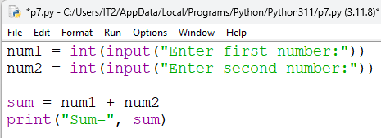
Output 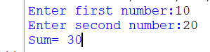

Program 8: Program to calculate total marks and percentage
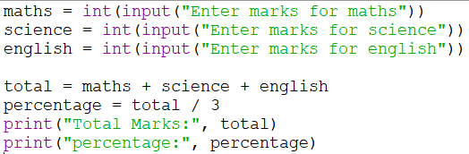
Output
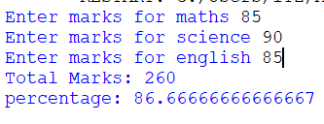

Program 9: Program to calculate average of three numbers.
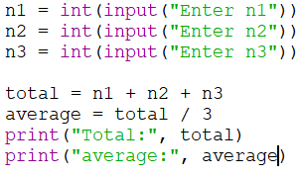

Output 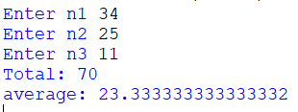

Program 10: Program to calculate simple interest.
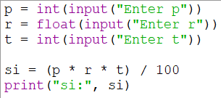
Output 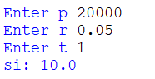

Program 11: Program to swap two variables
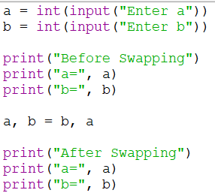
Output 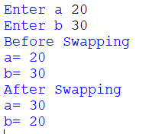

Program 12: Program to calculate area of rectangle.
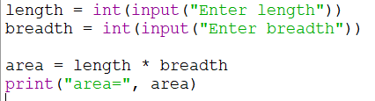
Output 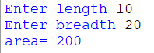

Program 13: Program to calculate area of circle.
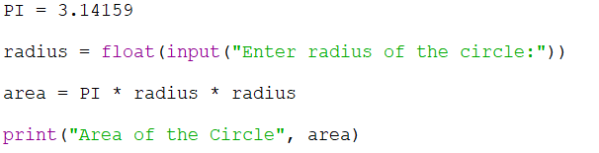
Output: 

